## **Asva Labs Whitepaper**

## **ABSTRACT**

Metaverse, the latest buzzword to pique the curiosity of the internet. The metaverse will give a complete virtual world experience where people can engage, communicate, and work together with each other on a global scale. More than a social environment, metaverse will nurture a business atmosphere for people from around the crypto space and blockchain industry. Advanced technologies like blockchain, A.I, V.R, and A.R will play a key role in accelerating the metaverse movement.

Although many comprehend the metaverse as a decentralized space, the lack of DeFi use cases and fundraising expansion frameworks in the cryptoverse arena leaves the concept blurry. Liquidity and passive income opportunities of virtual world assets are yet to be tapped into despite the massive growth of Play-To-Earn platforms. Considering the stimulating growth of Web3 and metaverse, it is still quite difficult for newcomers to access it. To add to that, the industry is scattered across various blockchain ecosystems and protocols.

## **ABOUT**

Asva Labs is a Metaverse innovation lab that aspires to build an Asvaverse ecosystem to integrate itself into the metaverse economy. The Asvaverse is planning to introduce its showcase products to the metaverse like, **The MetaLaunch** - a multi-chain launchpad and an incubator that supports a promising hand in raising capitals for entry level projects, **The Metaverse Marketplace**- a distinctive initiative where users can trade,launch and rent their metaverse assets and **Asva Gaming Guild** to power the Play-To-Earn model in the gaming community.

## **Vision**

**“We are leveraging on the web3 technologies of blockchain like DAO and NFTs to build an advanced metaverse economy in the crypto space”**

Asva Labs intends to build a MetaFi application that increases the productivity for virtual ownership of metaverse assets and brings a true essence of revolution into the metaverse.

**CHALLENGES**

## **1: Absence of DeFi infrastructure in the metaverse**

Due to the lack of a robust DeFi infrastructure it's difficult for many projects to provide staking and farming options in their project. This makes the projects difficult to get integrated into the metaverse completely. Lack of platforms that provide seamless staking, yield farming and lending features also causes a major drawback in finding an entrance to the metaverse for new projects.

## **2: Play-To-Earn platforms becoming more expensive**

Play-to-earn platforms built on blockchain play a major role in accelerating the metaverse development. With the rising cost of metaverse tokens and NFTs, it's largely inaccessible to new players. Early adopters, receiving rewards and privileges, have a clear edge against the newly joined players who enter the game in later phases. This results in the platforms failing to cater the gamers with small investments for a long run.

Another problem that holds back players from P2E is the lack of interoperability in the space. Supporters of a certain chain may not prefer interacting with platforms that run on other blockchain ecosystems.Amateur players find it difficult to get a grasp of the platforms and how they work owing to limited sources of training. Apart from this, most of the video gamers are unaware of the huge opportunities in the metaverse. Awareness and training programs are prerequisites to making P2E platforms mainstream.

## **3: Existing marketplaces failing to make an impact**

Apart from hosting a place for buying and selling NFTs, most NFT marketplaces fail to address the real needs of its users. When it comes to user experience and innovative features, they are still to keep pace with time. Current marketplaces lack immersive features and are unfit to provide scalability to current metaverse projects.

**4: Need for fundraising and Scope for growth**

The metaverse industry calls for intense research and development to manifest the way we imagine it today. Although there are many emerging projects with ambitious visions and business plans, not all of them can afford the massive capital requirements to run a successful project for a longer time. There is a lack of scope for growth and a huge need for fundraising frameworks like incubators and accelerators that extend support to early startups through initial grants which help to grow stronger and build a robust platform with a thriving ecosystem.

**FEATURES - Key Tenets of Asva Labs**

**1: DAO funding frameworks**

Asva Labs features DAO funding frameworks to emerging startups in the metaverse and gaming sector to raise capital and support its growth and development. This feature is dedicated just to the Meta Launch applications. In this way we extend our hands of support to the early supporters who join our ecosystem and be a part of us.

**2: Metaverse NFTs trade**

Asva labs has a robust marketplace where users can trade P2P based metaverse gaming assets. This provides a seamless trade volume of gaming assets in the metaverse. This also helps to establish a built-in marketplace supporting multi-chain metaverse projects in one ecosystem. With this Asva labs promotes an extensive support to buy and sell virtual world assets on its secondary marketplace and uplift the gaming experience on a whole new level.

**3: Monetize virtual ownership assets ( rent )**

Apart from buying and selling Asva Labs provides an opportunity to nft holders who can create monetization through their assets. They will be given an opportunity to rent their NFTs in the metaverse as gaming assets to players in the marketplace(ecosystem). Players can utilize the renting assets while playing games. This will help NFT holders to generate the gaming revenue which would be an additional way to earn income from NFTs. NFT holders can also rent their NFTS in metaverse to Creators and Artists. This will help the creators and artists to build concerts, virtual stores and launching events that will provide the real world experience in a virtual space.

**4: Guild opportunities**

The Gaming guilds will enhance play-to-earn games by providing efficient resources to players in the ecosystem. It promotes a guild system bringing together asset owners and gamers from all around the world in a common user-friendly virtual platform

**5: MetaFi DeFi Use Cases**

Asva Labs bring MetaFi DeFi use-cases by featuring them on staking and farming in our ecosystem projects and letting our users explore **various opportunities to earn staking benefits or earnings.**

**INTRODUCING ASVAVERSE ECOSYSTEM**

Asva Labs introduces some unique MetaFi solutions to enhance the utility of virtual-world assets and in turn, accelerate the growth of the metaverse economy.

# 

# **1: MetaLaunch**

# MetaLaunch, powered by Asva Labs, is the first-ever multichain metaverse launchpad and Incubator. It delivers strategic fundraising and growth frameworks to fuel virtual-world and gaming economies. The Asvaverse ecosystem also features MetaFi DeFi use cases, a metaverse marketplace, and play-to-earn guild integrations. The suite of MetaFi applications maximizes the productivity of virtual ownership assets.

# **MetaLaunch Tier System**

*MetaLaunch introduces a Tier structure, which aligns with goals of inclusivity and accessibility to valued and dedicated community members.*

***MetaLaunch features a three-round system***

* *The public round is where guaranteed tiers (****Meta-moon, Meta-Sun, and Meta-Galaxy*** *) can participate.*
* *In the Meta-community round, participants will actively engage in social activities and take part in a lottery.*
* *The FCFS round will be held if there are any unsold tokens remaining after the public and community round. The remaining allocations from the first and second rounds are distributed based on a first-come-first-served (FCFS) basis.*

*Read more:* [*https://medium.com/@asvalabs/introduction-to-the-metalaunch-tier-system-4bb7bbea46ff*](https://medium.com/@asvalabs/introduction-to-the-metalaunch-tier-system-4bb7bbea46ff)

**$ASVA Staking System**

ASVA Staking program on MetaLaunch is Live now. MetaLaunch supports both ASVA Single asset and LP staking.Users will receive attractive APR benefits based on the stake duration they choose.

**How to Stake Your ASVA Single Asset and LP Staking : A Step By Step Guide :** [**https://asvalabs.medium.com/asva-staking-on-metalaunch-goes-live-2cad20fc91a8**](https://asvalabs.medium.com/asva-staking-on-metalaunch-goes-live-2cad20fc91a8)

## **Metaverse Marketplace**

Metaverse Marketplace is made up of three pillars, which are Trade, Rent and Launch, for virtual property, virtual lands, play to earn assets, and metaverse NFTs.

Launch: Marketplace's primary purpose is to support initial NFT offerings (INOs) from different metaverse gaming projects

Rent- Empower creators and builders to monetize their metaverse NFTs.

Trade - Our Marketplace enables trading of NFTs and Metaverse assets where users can Buy, sell and launch metaverse assets.

The world's first marketplace dedicated to trading and renting virtual ownership-based metaverse assets, such as virtual real estate, metaverse assets, and play-to-earn assets. By using the platform built for the metaverse industry, users will be able to trade and rent assets from the top metaverse projects and gaming projects.

MetaLaunch aim to build monetary value for NFTs holders by allowing them to rent their assets to borrowers without giving ownership, with borrowers being creators they can leverage the assets that they rent, create income, and give a portion of that income to the asset holders.

**MetaRent**

The Collateralize free Metaverse Renting

Renting features have been introduced to the metaverse marketplace to provide monetisation opportunities to the NFT holders in the form of rentals.

**Renting feature is available on** —

* Virtual real estate
* Play to earn game assets
* Metaverse NFTs

**Asva Gaming Guild**

ASVA gaming guild is focused on providing the gaming community an access to the best Play-To-Earn ecosystem by providing resources like NFTs, training and support to players who are willing to get an entry into these ecosystems. This will be under ASVA guilds for various P2E games like axie infinity, splinterlands, thetan arena, PegaXY etc.

Eventually ASVA gaming guild will be a DAO of like-minded individuals who come together due to their mutual interests to play games, have fun and get rewarded for their efforts and time.

Part of the ASVA Labs ecosystem. Asva gaming guild has synergistic relations with other ASVA labs products such as MetaLaunch, which position us uniquely to be involved in every aspect of blockchain gaming from launch of projects tokens and metaverse marketplace to trade metaverse assets

**MetaFi DeFi vault**

The MetaFi DeFi platform offers staking and farming functionality to ecosystem projects so that users can explore various ways to earn staking benefits.

Asva MetaFi DeFi Vault aims to provide support to liquidity pools and claim APYs through yield farming and ASVA token staking. New projects can avail the vault’s services for their various requirements.

**PRODUCT AUDIT STATUS**

All our products undergo comprehensive security audits prior to launch. Find the audit reports here:

ASVA token contract [audit report](https://github.com/asvalabs/AsvaLabs_Docs/blob/master/ASVA%20Smart%20Contract%20Audit%20Report%20-%20QuillAudits.pdf) - Quillhash

MetaLaunch product [audit report](https://hacken.io/audits/#metalaunch_(asva)) - Hacken

**ROADMAP 2022**

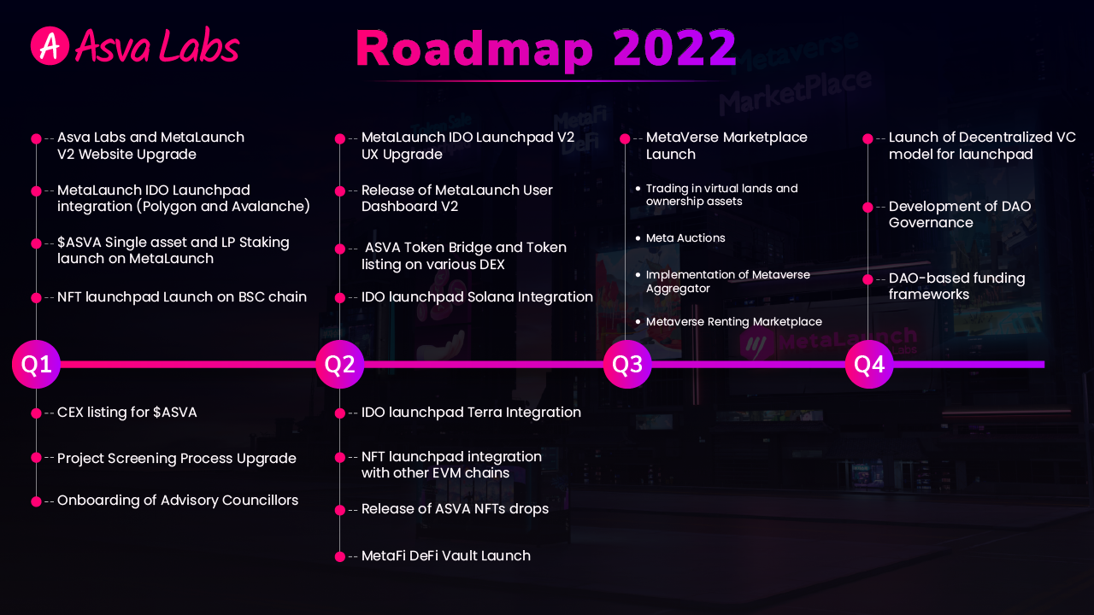

***Building the infrastructure that will facilitate the development of play-to-earn gaming & the metaverse enhancing the productivity of virtual ownership assets***

**This article will give an overview of our upcoming milestones for 2022:** [**https://medium.com/@asvalabs/asva-labs-roadmap-meta-mania-to-rule-2022-f99c18a867b**](https://medium.com/@asvalabs/asva-labs-roadmap-meta-mania-to-rule-2022-f99c18a867b)

**TEAM AND ADVISORS**

## **Led by industry experts**

Asva is driven by a team of entrepreneurs, tech developers, marketing experts, and fintech professionals unified by a forward-looking vision for the Web 3.0 technology. Our excellent track record and expertise in diverse fronts will be harnessed for the growth of the industry as a whole.

**IMAGE**

**INVESTORS AND PARTNERS**

**We have joined forces with some of the top-tier projects in the industry.**

**IMAGE**

**Branding and media kit**

**COMMUNITY**

# **Community Rewards Engagement Program Worth $1 Million ASVA**

We launched our first community engagement program for 2022 for the members who want to involve themselves in the project and play an active role in the growth of the Asva Ecosystem

Learn More: <https://medium.com/@asvalabs/introducing-metalaunch-asva-community-rewards-engagement-program-worth-1-million-asva-9448975d3c8a>